Project Development Phase
Model Performance Test

Date | 20 February 2026
Team ID | LTVIP2026TMIDS52591
Project Name | Exploratory analysis of rain fall data in india for agriculture
Maximum Marks | 10 Marks

Model Performance Testing:
Project team shall fill the following information in model performance testing template.
S.No | Parameter | Values | Screenshot
1 | Confusion Matrix | Generated using sklearn.metrics.confusion_matrix | 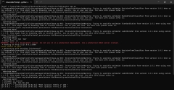
2 | Accuracy Score | Generated using sklearn.metrics.accuracy_score | 
3 | Classification Report | Precision, Recall, F1-Score using sklearn.metrics.classification_report | 

